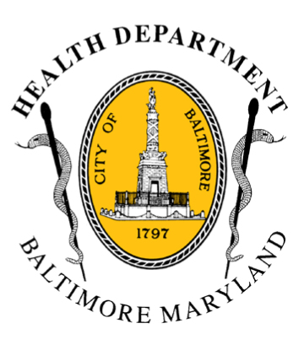
BCHD PRESS RELEASE
Baltimore City Health Department
1001 E. Fayette Street • Baltimore, Maryland 21202
Stephanie Rawlings-Blake, Mayor
Leana Wen, M.D., Commissioner of Health

FOR IMMEDIATE RELEASE
Media Contact: Michael Schwartzberg, PIO
O: (443) 984-2623 C: (443) 462-7939 E: michael.schwartzberg@baltimorecity.gov
City Agencies & Private Sector Partnering To Deliver Counseling
And Mental Health Services to
Communities Impacted by Violence and Civil Unrest

BALTIMORE, MD (April 29, 2015) – In response to the tragic events that have struck Baltimore, Mayor Stephanie Rawlings-Blake and Baltimore Health Commissioner Dr. Leana Wen are coordinating efforts across multiple city agencies and private organizations to address the trauma that many individuals in the community are experiencing. As part of this effort, the Baltimore City Health Department will be working with schools, churches and community organizations to provide supportive counseling services to communities impacted by recent events.

“We are in the midst of a crisis, but we need to begin to heal,” said Rawlings-Blake. “This has been a very traumatic event for many in our community, and many will need to process it with professionals specializing in mental health counseling.”

The citywide trauma counseling/mental health response includes:
- Ensuring 24/7 availability of mental health crisis services;
- Providing group counseling and support for community members through schools, religious institutions, and community organizations;
- Coordinating availability of mental health resources and matching them with ongoing need to promote citywide healing.

To access services:
- For crisis services, call Baltimore Crisis Response at 410-433-5175.
- Individuals and families who need assistance scheduling an appointment for mental health services, should call Behavioral Health System Baltimore at 410-637-1900, option #1.
- Services for groups can be accessed by calling 311 and asking to be referred to the Health Department’s mental health providers, or by sending an email to bchd2@baltimorecity.gov.

- more -

2-2-2

“Our city is experiencing a terrible tragedy and terrible trauma,” said Dr. Wen. “Addressing trauma at the community level is an integral part of the recovery process, and we need to treat trauma just as we would with any other disease.”

Participating city agencies include: Mayor’s Office, Baltimore City Health Department, Baltimore City Public Schools, Mayor’s Office of Criminal Justice, and Mayor’s Office of Neighborhoods. Private sector partners include: the American Red Cross, Behavioral Health System Baltimore, Baltimore Crisis Response Inc. and Baltimore Child and Adolescent Response System.

A number of mental health providers have agreed to expand their services, and the American Red Cross is deploying teams of volunteer mental health professionals for needs citywide.

Groups from the city’s religious institutions, community groups, and schools are being asked to identify where the need for counseling services exists and to facilitate meetings where the professionals can provide assistance for multiple individuals.

“We will come to your church, your neighborhood organization, and your schools to provide counseling,” said Dr. Wen. “Please tell us where to go; call us at 311 or email bchd2@baltimorecity.gov.”

###

